1. A QA tester is hired on contract for exactly one week to test something on your

staging server. Following are the things you must provide him:

1. An user account called “qa” with login access to your server, but you don’t want to trust yourself or anyone else to remember to disable the account once the week is done.

2. You want the system itself to revoke access after the agreed time.

Ans : sudo useradd qa -m -s /bin/sh -e `date -d "7 days" +"%Y-%m-%d"`

sudo passwd qa

2. You’re monitoring the server and notice high CPU usage. On investigation, you find a

background job running uncontrolled. You must:

1. Find the process and kill it.

2. Ensure it has been successfully killed. If not so, investigate further and try to kill it.

Ans : htop

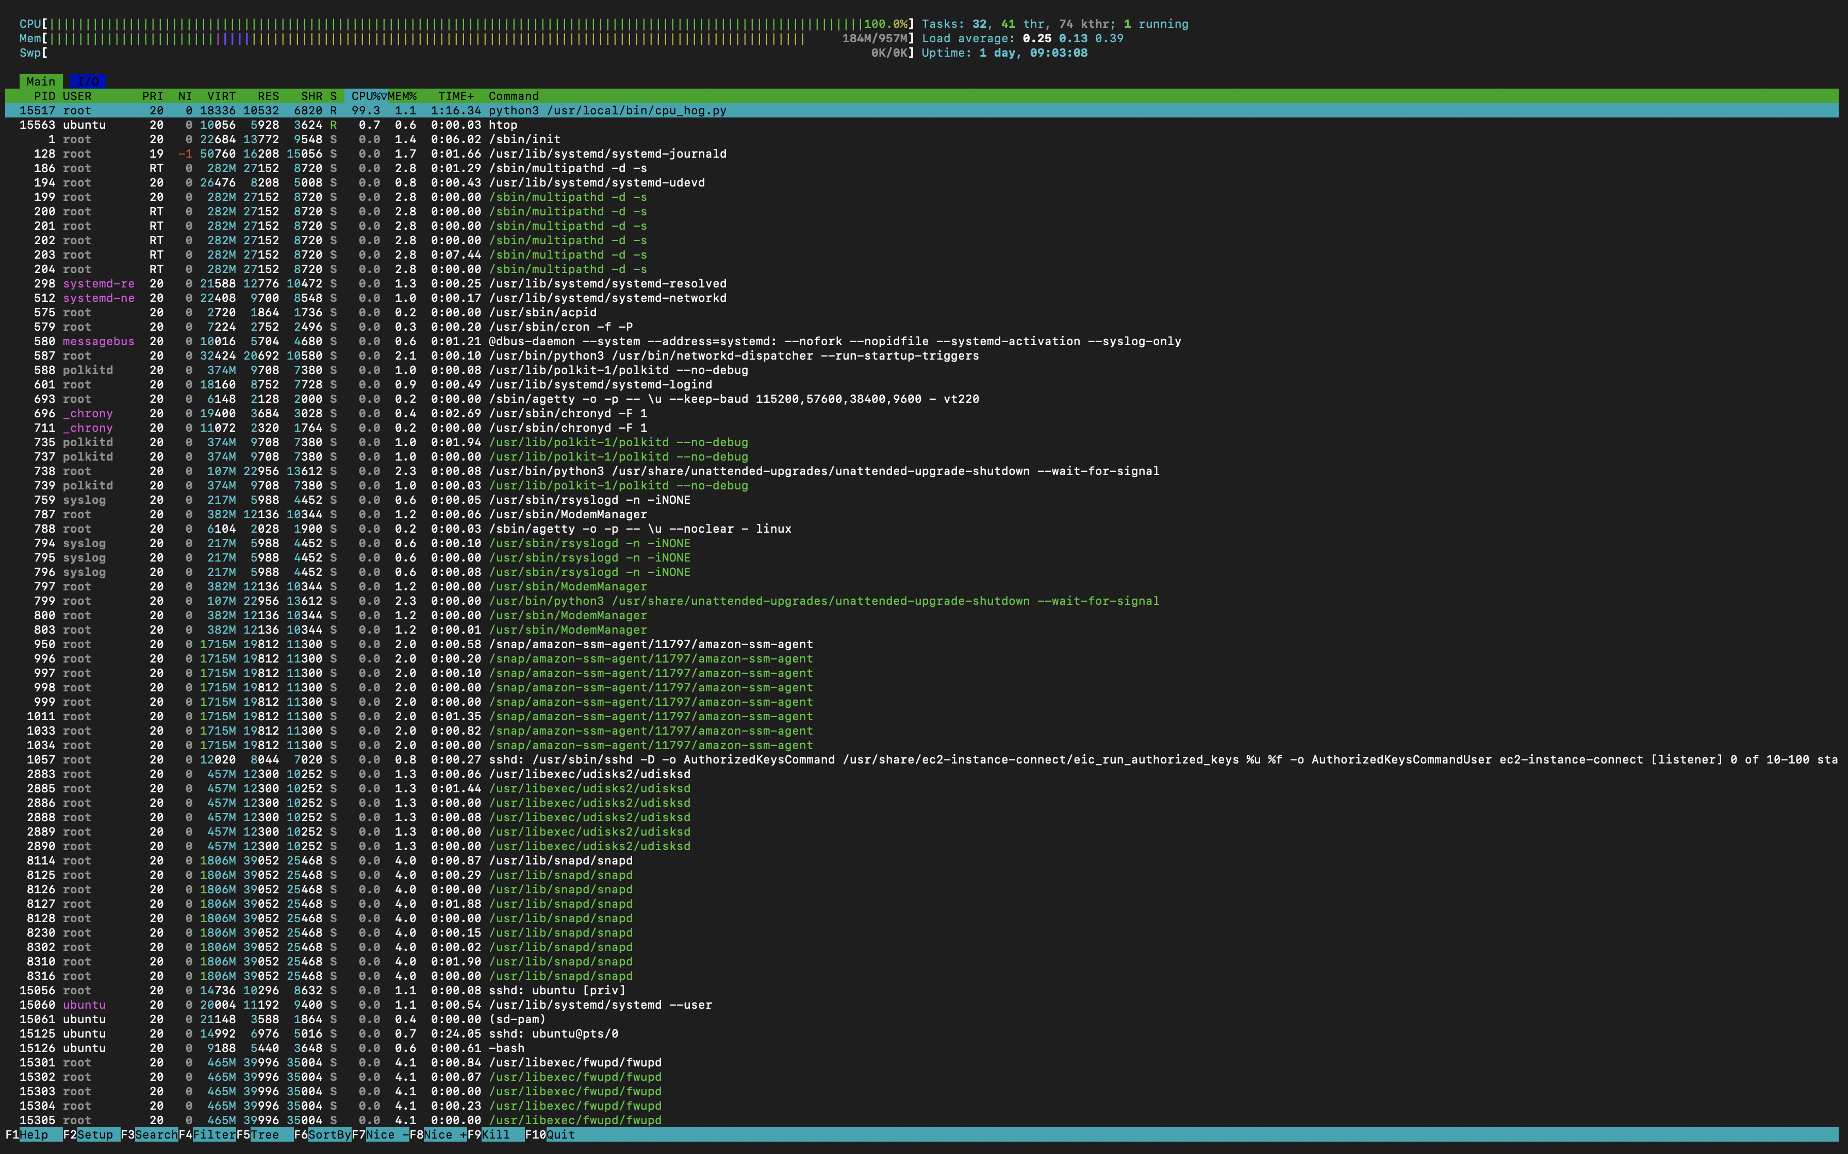

systemctl status 15517

sudo systemctl stop cpu-hog.service

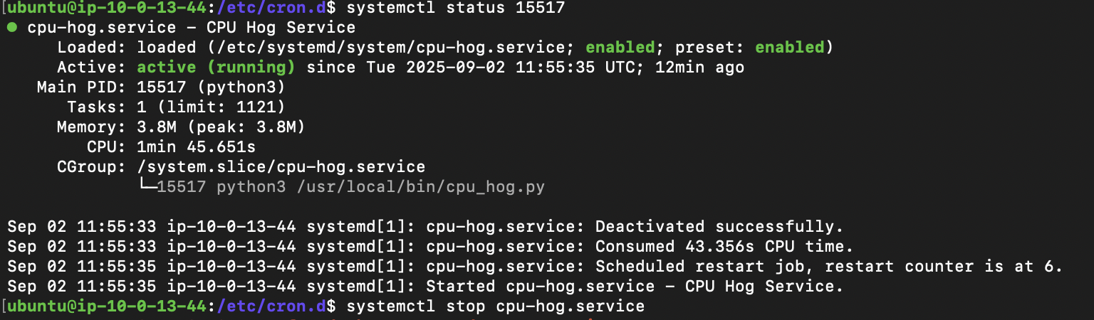

3. Two engineers (u1, u2) are collaborating in /srv/shared. They both need to write files,

but neither should be able to delete the other’s files.

1. Create users u1 and u2 in your system.

2. Set up /srv/shared so both users can create files.

3. Enforce that only file owners can delete their files.

Ans : sudo useradd u1

sudo useradd u2

sudo passwd u1

sudo passwd u2

sudo groupadd u1u2

sudo usermod -aG u1u2 u1

sudo usermod -aG u1u2 u2

sudo mkdir /srv/shared

sudo chown : u1u2 /srv/shared

sudo chmod 2777 /srv/shared

sudo chmod +t /srv/shared

4. Imagine you're a system administrator tasked with monitoring the performance of

several servers running GNU+Linux in a data center. To effectively track CPU usage,

memory consumption, disk I/O, and network statistics. The node-exporter package is

already downloaded for you at /home/ec2-user/node_exporter.tar.gz. Your goal is to

place the binary in the right path, and create a systemd service to run it all the time.

Ans : tar -xvzf node_exporter.tar.gz

nano node_exporter.service

mv node_exporter.service /etc/system/system/

sudo systemctl daemon-reload

sudo systemctl start node_exporter.service

node_exporter.service :

[Unit]

Description=Node Exporter

After=network.target

[Service]

ExecStart=/home/ubuntu/node_exporter-1.9.1.linux-amd64/node_exporter

Restart=always

RestartSec=5s

[Install]

WantedBy=default.target

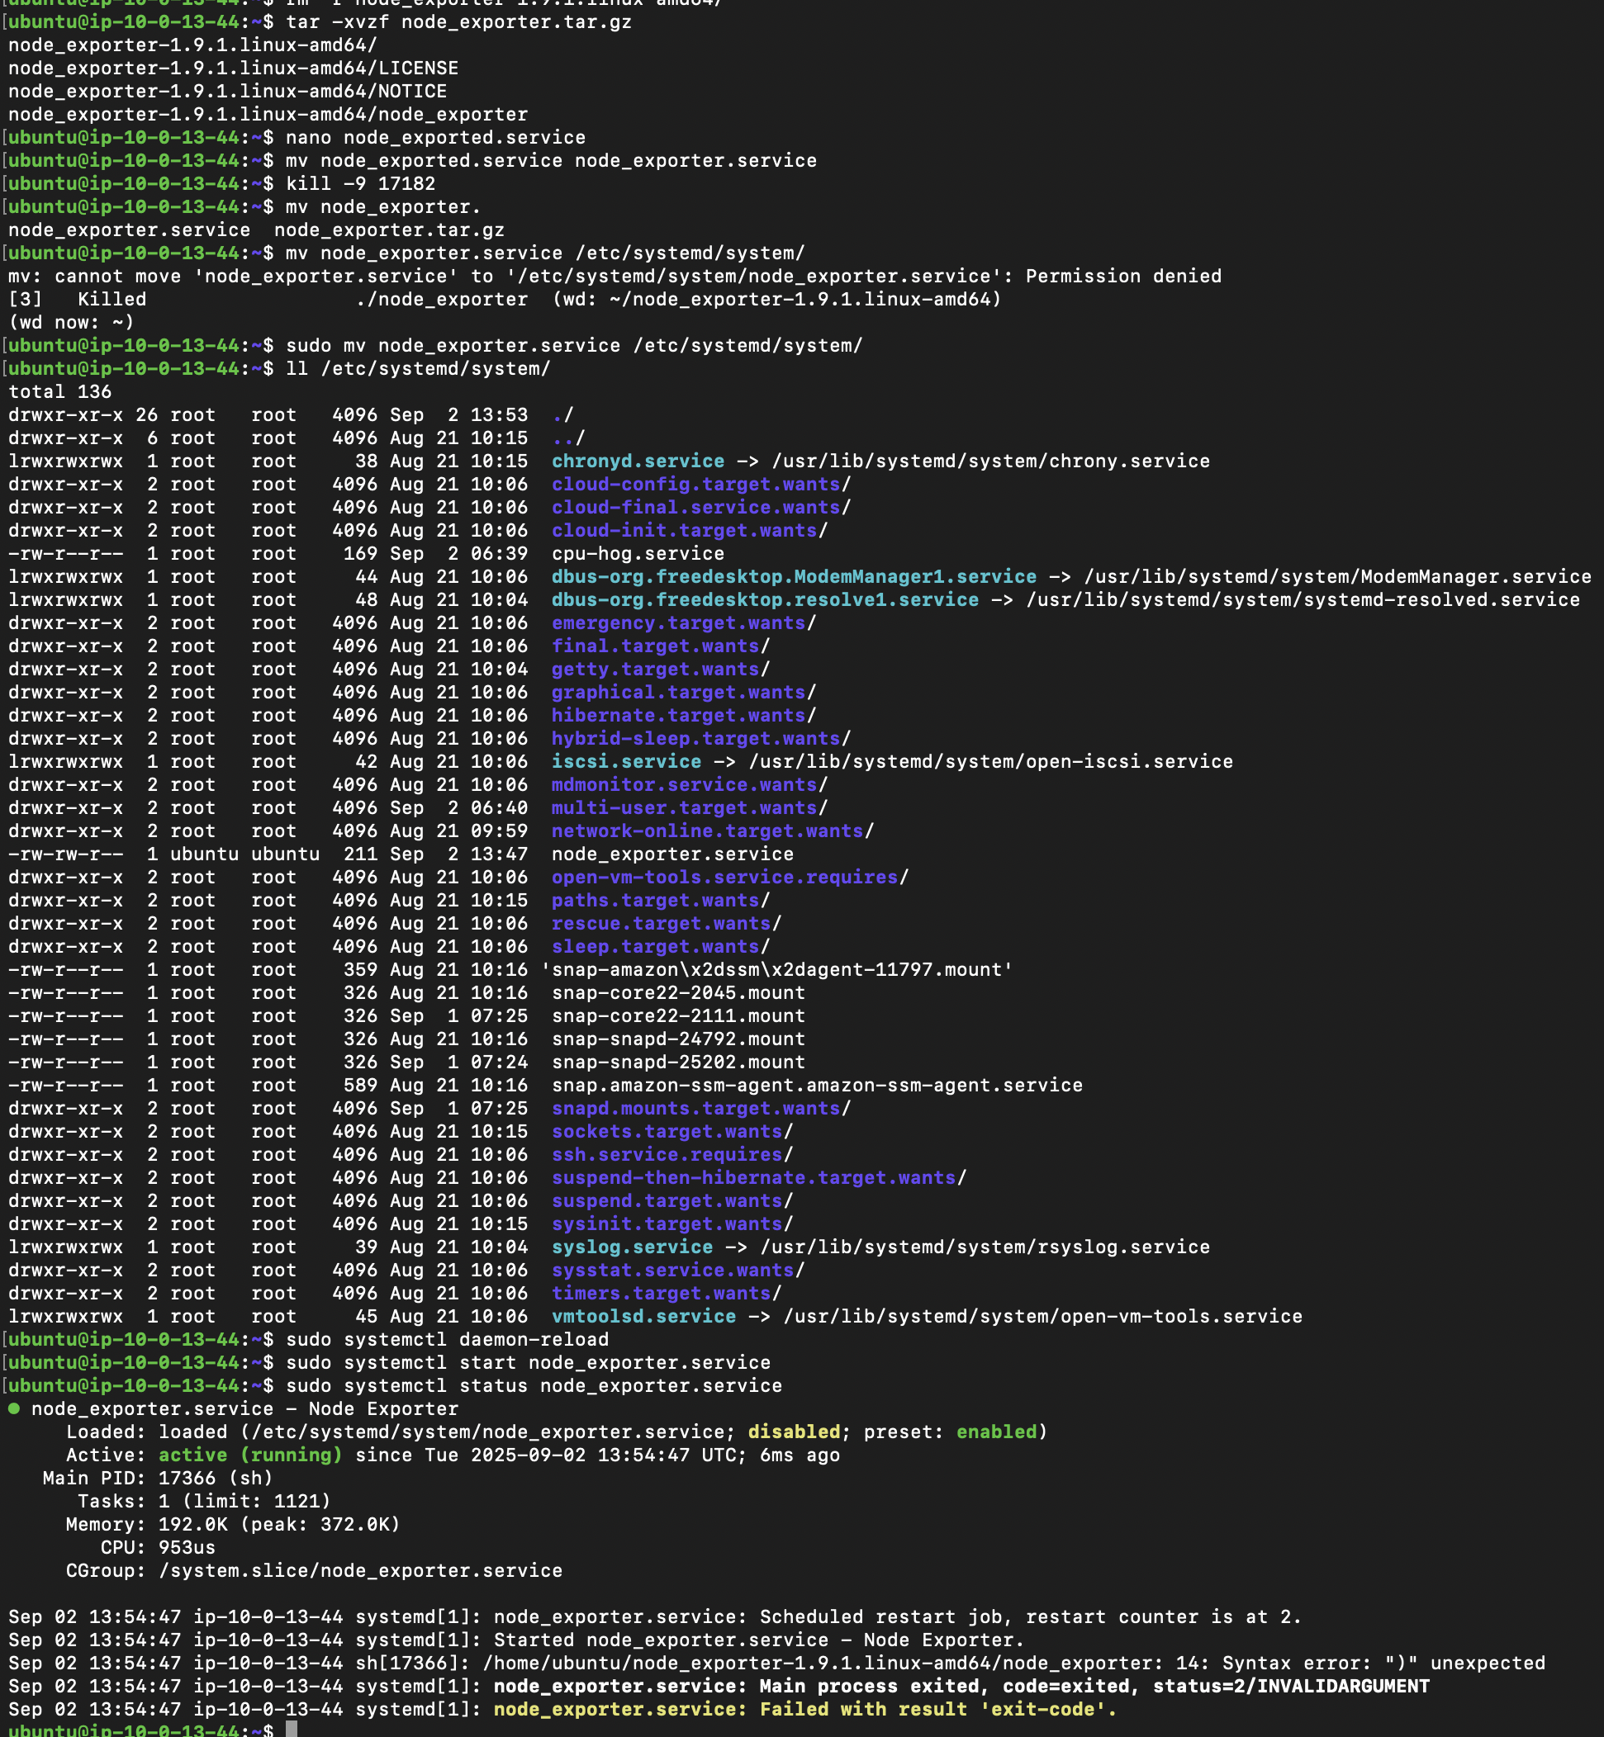

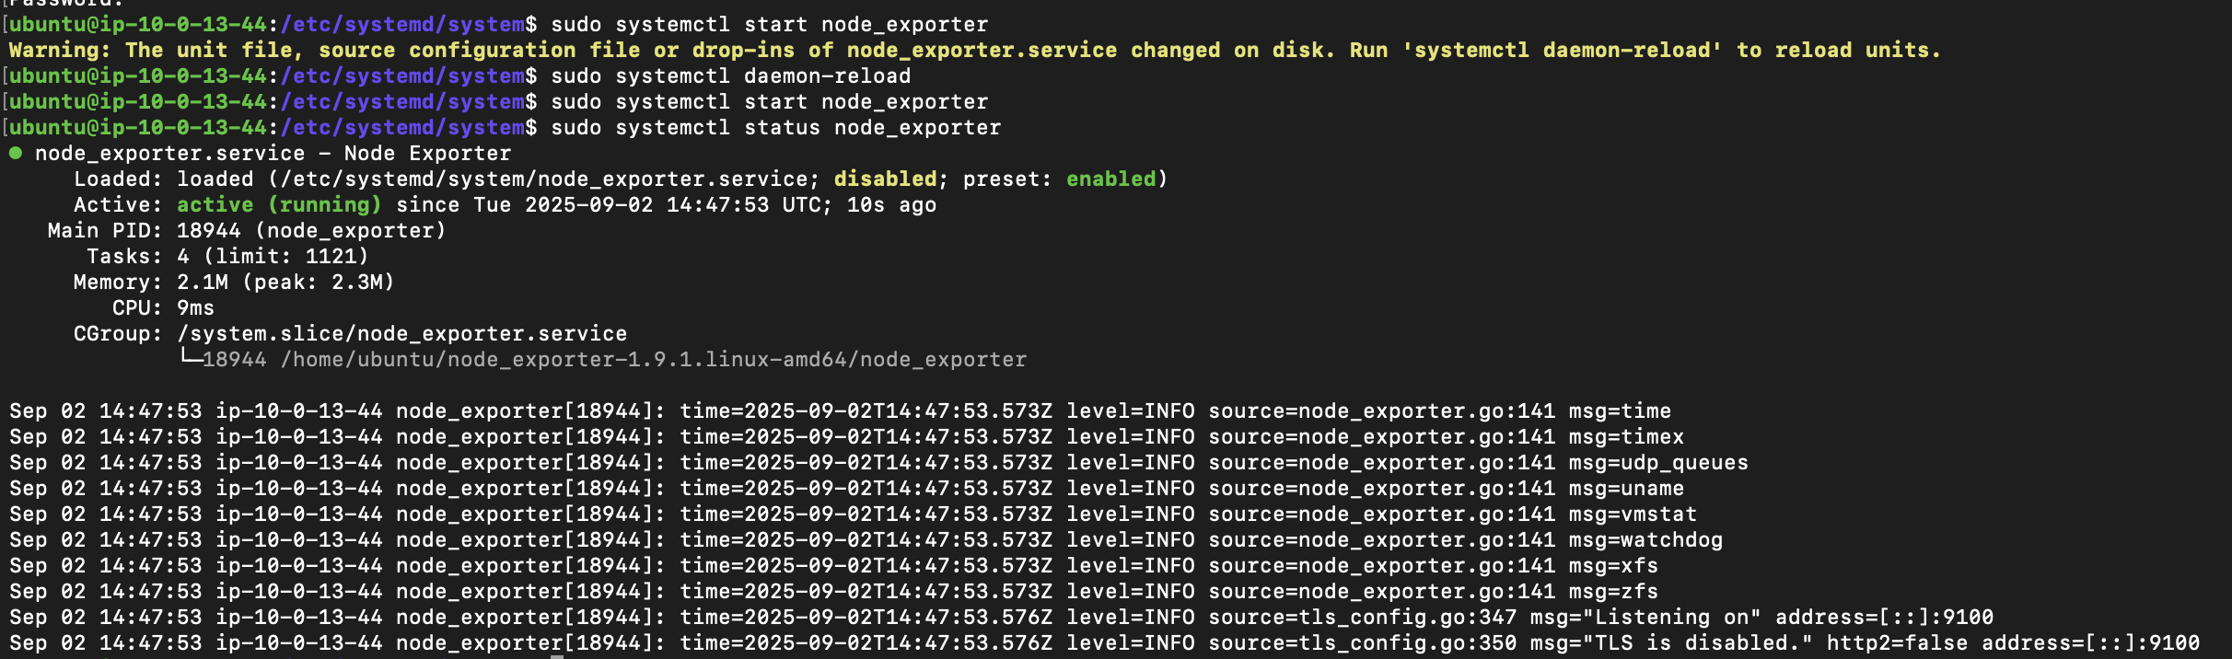

5. You’re working on a cloud-hosted VM and you find that your team is using a

password to gain sudo access. Your goal is to allow users to elevate privileges with

sudo without the root password and run any command. Ensure you only allow login

via SSH only with a private key for that user.

Ans : u1 ALL=(ALL:ALL) NOPASSWD:ALL

Server :

sudo useradd -m user1

cd /home/user1

ssh-keygen -t rsa -b 4096 -m PEM -f ~/.ssh/user1-login.pem -C "user1@vm"

cat ~/.ssh/user1-login.pem.pub >> ~/.ssh/authorized_keys

chmod 600 ~/.ssh/authorized_keys

chmod 700 ~/.ssh

Local machine :

scp hayagreevan@192.168.1.8:/home/user1/.ssh/user1-login.pem ~/Desktop

ssh -i ~/.ssh/user1-login.pem user1@192.168.1.8

Resources:

Man pages - useradd, date, htop, kill, ps, chmod

<https://rm-rf.medium.com/install-node-exporter-for-prometheus-grafana-d0ec29b8a2b6>

<https://blog.nashtechglobal.com/mastering-systemd-creating-custom-services-on-linux/>

<https://linuxize.com/post/how-to-list-groups-in-linux/>

<https://chatgpt.com/share/68b7ed1b-c6c4-800a-b91d-32987646aaf9>

<https://www.cyberciti.biz/faq/linux-logout-user-howto/>